**Abstract:** This documentation outlines the implementation and evaluation of a Random Forest Classifier applied to the Iris dataset. Leveraging the scikit-learn library, the classifier is trained on relevant features, and its predictive performance is assessed using accuracy metrics, confusion matrix, and classification report.

**Introduction:** Random Forests are a popular ensemble learning technique widely used in machine learning for classification tasks. This documentation focuses on the application of a Random Forest Classifier to the Iris dataset. The Iris dataset is a well-known benchmark in machine learning, featuring botanical measurements of iris flowers.

**Related Work:** Random Forests have been extensively studied and utilized in various machine learning applications. The ensemble method builds multiple decision trees and aggregates their predictions, providing improved accuracy and robustness. The scikit-learn library offers a robust implementation of Random Forests, making it accessible for practitioners and researchers.

**Description of Applied Method:** The implementation utilizes the scikit-learn library to create a Random Forest Classifier. The Iris dataset is loaded and preprocessed, with relevant features selected. The data is then split into training and testing sets. The Random Forest Classifier is instantiated with 100 decision trees and trained on the training set. Predictions are generated on the test set, and the model's performance is assessed using accuracy, confusion matrix, and classification report metrics.

**Results:** The Random Forest Classifier is applied to the Iris dataset, and the evaluation results are printed. The accuracy of the model, along with the confusion matrix and classification report, provides a comprehensive overview of its performance on the test set. These metrics help assess the classifier's ability to correctly classify iris flower species based on their botanical measurements.

- Confusion Matrix

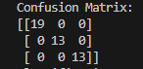

- Accuracy Score



- Classification Report

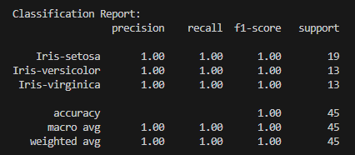

**Conclusion:** In conclusion, the Random Forest Classifier demonstrates its effectiveness in classifying iris flowers based on botanical features. The documentation provides a straightforward example of applying the scikit-learn RandomForestClassifier to a real-world dataset. The evaluation results offer insights into the model's accuracy and its ability to handle multi-class classification. Users can leverage this implementation as a foundation for understanding and applying Random Forests in their own machine learning projects.